A000-US-SD-Lakota-Shaman’s Turtle Shell Rattle-1790's to 1840's

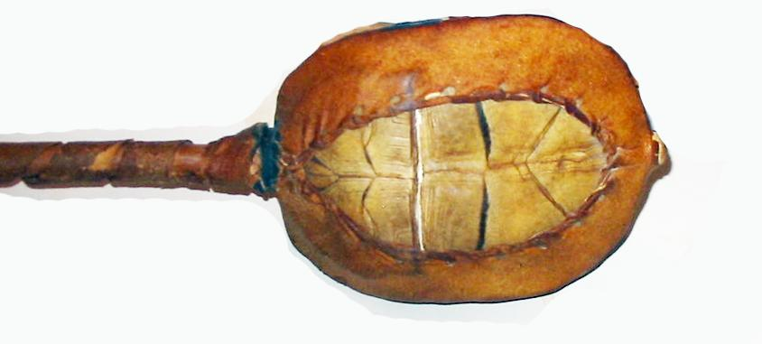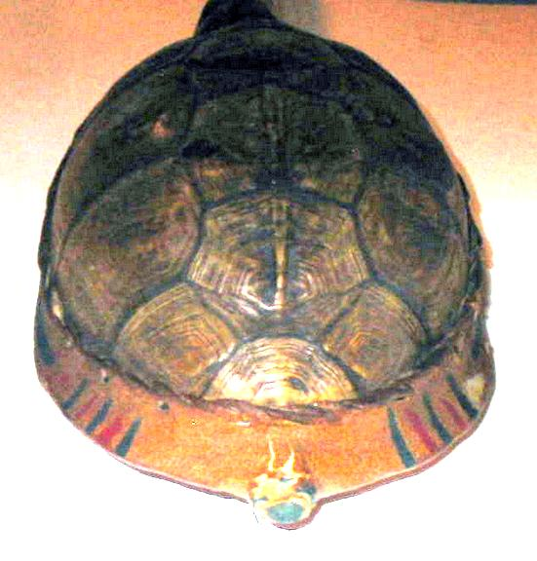

Lakota-Shaman’s Turtle Shell Rattle-1790's to 1840's Value $2,000

**Case No.: 12**

**Accession No.**

**Formal Label:** Lakota-Shaman’s Turtle Shell Rattle-1790's to 1840's

**Display Description:**

Lakota-Shaman’s Turtle Shell Rattles provided the rhythm that is essential to entering into deep meditation and dances. Furthermore the red and green lines on the rawhide tympanum indicate the past and present of the moments that the turtle shell is meant to direct one’s attention, back and forward. These rattles were also used later during the traditional circle dances and the Ghost Dances.

**LC Classification:**

**Date or Time Horizon:** 1790's to 1840's

**Geographical Area:**

**Map:**

**GPS coordinates:**

**Cultural Affiliation:**

**Media:**

**Dimensions:**

**Weight:**

**Condition:**

**Provenance:**

**Discussion:**

**References:**